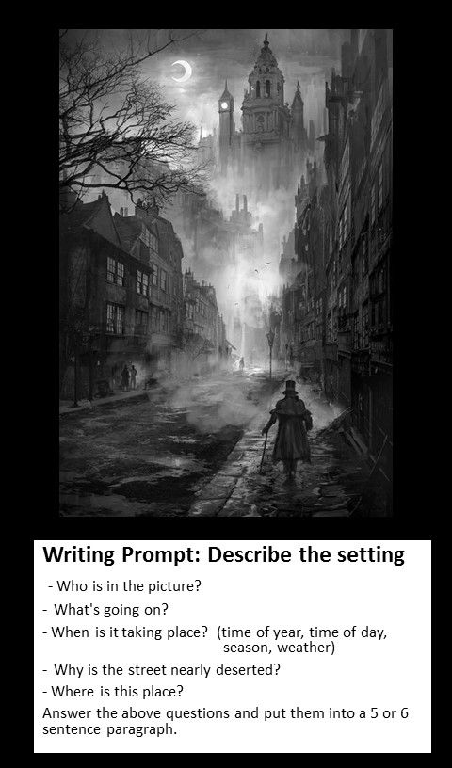Writing Prompt 1- October

**Writing Prompt**: October 6th, 2016

**Subject**: Describe the setting

In your own words, write a ten sentence paragraph describing this setting and explaining what is going on in the picture.

Things to consider:

-Who is this person in the picture, and what are they doing?

-When is this taking place?

-Where is this area?

-where is everyone else?

-Please use complete sentences, punctuation and a paragraph format.

(CCSS. ELA-Literacy.W.8.3)